*2025* Upcoming Events *2025*

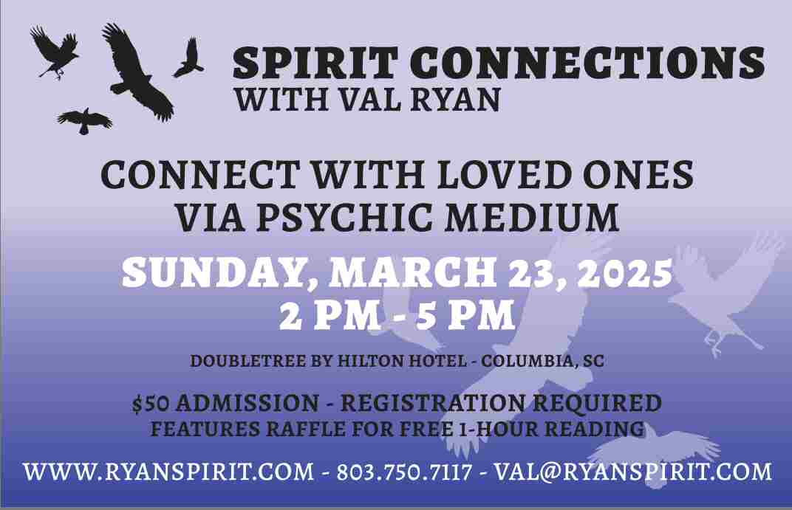

Another event is scheduled for Sunday, September 21, 2025 from 2:00pm until 5:00 pm at the Doubletree Inn. Cost for event is $50.00.

Please join me for a time of spirit communication. I'll contact your passed loved ones, spirit guides and past lives. Bring a photo of someone you'd like to contact with. While not necessary, it can be helpful. And, I'll discuss the process, helping you to connect on your own.Then, stay for further discussion and Q&A.

Please let me know if you'd like to attend and how many. Thank you.

Host Your Own Gathering – Spirit Connections
Please visit the Spirit Connections page for details or contact me for an estimate.

Mini Spirit Connections
I offer Mini Spirit Connections in my home. Please visit the Spirit Connections page for details or contact me for an estimate.

Private Readings
$150.00 per hour for In Person, By Phone and Skype Readings.
$85.00 for ½ hour Phone Reading.
All phone readings require payment in advance.

SERVICES
Psychic, Medium, Tarot, Dreams, Numerology, Feng Shui, Spirit Cleansings, Life Coaching and more. Please visit the Services page for details.

